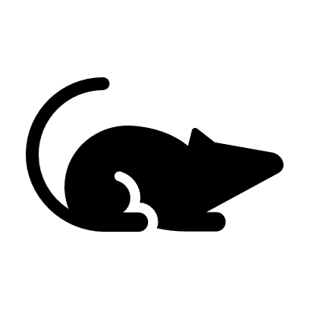

**Kev Tsim Kho thiab Kev Pom Zoo Ntawm**

**Cov Tshuaj Tiv Thaiv Kab Mob COVID-19**



**Txheej Txheem Kev Pom Zoo Ntawm Cov Tshuaj Tiv Thaiv Kab Mob**

Txhawm rau kev pab kom tsim nyog lossis lwm txoj haum kev xais thov hu rau Minneapolis lub tsev saib xyuas kev noj qab hauv huv ntawm 612-673-2301 lossis [covid19@minneapolismn.gov](mailto:covid19@minneapolismn.gov). Cov neeg lag ntseg lossis tsis hnov lus zoo tuaj yeem siv kev pab cuam hu 311 at 612-673-3000. Cov siv TTY tuaj yeem siv tau 612-263-6850. Yog xav tau kev pab,hu 612-673-2700, Yog xav tau kev pab, hu 612-673-2800, Yog tias koj xav tau kev pab, hu 612-673-3500.

**Txhawm rau cov ntaub ntawm ntxiv, mus xyuas** [**http://www2.minneapolismn.gov/coronavirus/vaccines**](http://www2.minneapolismn.gov/coronavirus/vaccines)

Kev tso cai siv uas muaj xwm txheej ceev yuav tsum tau tshuaj xyuas thiab Pom zoo los ntawm Chaw Tswj Xyuas Khoom Noj thiab Tshuaj (FDA). Chaw FDA soj ntsuam tag nrho muaj cov ntaub ntawv tshawb fawb txog kev txiav txim siab tias qhov tshuaj tiv thaiv kab mob muaj kev nyab xeeb thiab zoo ua ntej tsos cais.

Hauv nroog Minnesota, kev txhaj tshuaj tiv thaiv kab mob pib thaum ib nrab lub Kaum Ob Hlis 2020.